Name: _________________________ Narrogin Senior High School


Unit 4 Modern History

SOURCE ANALYSIS ONE

The Changing European World Since 1945

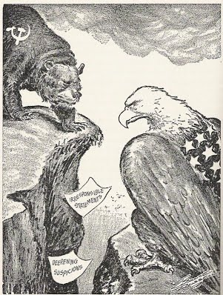

Marks out of 25:

Weighting - 5 %

SECTION ONE: SOURCE ANALYSIS SET 1, Unit 4

This section has ONE question made up of FIVE (5) parts. Attempt ALL parts. Write your answers in the spaces provided.

- The marks allocation for this section is 25 marks.

- Allow approximately 45 minutes for this section.

Indicate below the document set from the Document Booklet you will use to respond to this
question.

Set 1: □ The changing European world since 1945

Set 2: □ Australia’s engagement with Asia

Set 3: □ The struggle for peace in the Middle East

Question 1

- Explain the historical context of Source 1. Include the relevant events, people and ideas depicted or represented in the source. (4 marks)

SOURCE ANALYSIS SET 1 cont…

(b) Compare and contrast the purpose of Sources 1 and 2. (5 marks)

(c) Describe the message and tone of Source 3. (3 marks)

- SOURCE ANALYSIS SET 1 cont…

(d) Identify and discuss why Sources 3 and 4 are contestable. (6 marks)

SOURCE ANALYSIS SET 1 cont…

(e) Using your knowledge of the whole period of study, evaluate the importance of the
themes, ideas and/or events represented in the four sources. (7 marks)

END OF SECTION FOUR

Question number:

Question number:

Source 1
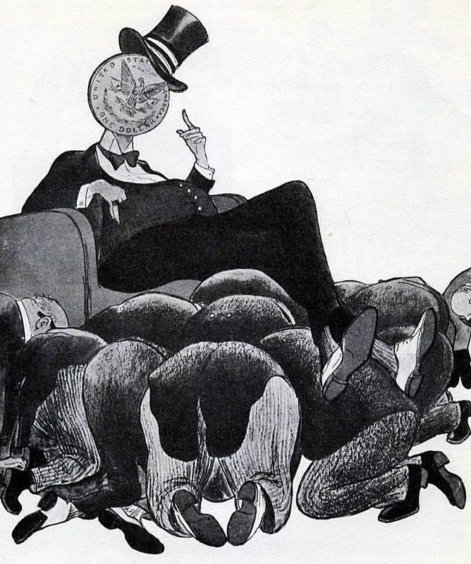
This cartoon of 1947, from a Soviet magazine, had the caption ‘Capitalist Europe on the Upswing’

Source 2

Communisim in Eastern Europe 1945-1948
Country | Date | Method
Albania | 1945 | The Communists immediately took power.
Bulgaria | 1945 | In the 1945 elections, a Communist-led coalition was elected, but the Communists executed the non-Communists.
East Germany | 1945 | East Germany was the Soviet zone of Germany. In 1949, they set up a Communist-controlled state called the German Democratic Republic.
Romania | 1947 | In the 1945 elections, a Communist-led coalition was elected to power. The Communists gradually took over and in 1947 they abolished the monarchy.
Poland | 1947 | Stalin had promised to set up a joint Communist/non-Communist government at Yalta, but then he invited 16 non-Communist leaders to Moscow and arrested them. Thousands of non-Communists were arrested, and the Communists won the 1947 election.
Hungary | 1947 | The non-communists won the 1945 elections with Zoltan Tildy as president. However, the Communists' leader, Rakosi, took control of the secret police (the AVO), and executed and arrested his opponents. Tildy was forced to resign and Cardinal Mindzenty, head of the Catholic Church, was imprisoned. By 1948, Rakosi had complete control of Hungary.
Czechoslovakia | 1948 | A coalition government was set up and led by the non-Communist Benes. However, the Communists' leader Gottwald made sure they controlled the radio, the army and the police. Gottwald became prime minister and set up a secret police force. Non-Communists were arrested. In 1948, Communist workers went on strike, the non-Communist minister Masaryk committed suicide and Gottwald took over the government.

GCSE BBC educational website: http://www.bbc.co.uk/schools/gcsebitesize/history/mwh/ir2/sovietexpansionineasterneuroperev2.shtml 2014

Source 3
“We have to consider seriously and analyse correctly [the crimes of the Stalin era] in order that we may preclude any possibility of a repetition in any form whatever of what took place during the life of Stalin, who absolutely did not tolerate collegiality in leadership and in work, and who practised brutal violence, not only toward everything which opposed him, but also toward that which seemed to his capricious and despotic character, contrary to his concepts.

Stalin acted not through persuasion, explanation, and patient cooperation with people, but by imposing his concepts and demanding absolute submission to his opinion. Whoever opposed this concept or tried to prove his viewpoint, and the correctness of his position, was doomed to removal from the leading collective and to subsequent moral and physical annihilation. This was especially true during the period following the XVIIth Party Congress [1934], when many prominent Party leaders and rank-and-file Party workers, honest and dedicated to the cause of Communism, fell victim to Stalin's despotism. . . .

Stalin originated the concept enemy of the people. This term automatically rendered it unnecessary that the ideological errors of a man or men engaged in a controversy be proven; this term made possible the usage of the most cruel repression, violating all norms of revolutionary legality, against anyone who in any way disagreed with Stalin, against those who were only suspected of hostile intent, against those who had bad reputations. This concept, enemy of the people, actually eliminated the possibility of any kind of ideological fight or the making of one’s views known on this or that issue, even those of a practical character. In the main, and in actuality, the only proof of guilt used, against all norms of current legal science, was the "confession" of the accused himself; and, as subsequent probing proved, confessions were acquired through physical pressures against the accused.

This led to the glaring violations of revolutionary legality, and to the fact that many entirely innocent persons, who in the past had defended the Party line, became victims. . . .

The Commission [of Inquiry] has become acquainted with a large quantity of materials in the NKVD archive and with other documents and has established many facts pertaining to the fabrication of cases against Communists, to false accusations…….. which resulted in the death of innocent people. It became apparent that many Party, Soviet and economic activists who were branded in 1937-1938 as enemies were actually never enemies, spies, wreckers, etc., but were always honest Communists; they were only so stigmatised, and often, no longer able to bear barbaric tortures, they charged themselves with all kinds of grave and unlikely crimes. . . .

………Stalin, on the other hand, used extreme methods and mass repression at a time when the revolution was already victorious, when the Soviet state was strengthened, when the exploiting classes were already liquidated and Socialist relations were rooted solidly in all phases of national economy, when our Party was politically consolidated and had strengthened itself both numerically and ideologically. It is clear that here Stalin showed in a whole series of cases his intolerance, his brutality and his abuse of power. Instead of proving his political correctness and mobilising the masses, he often chose the path of repression and physical annihilation, not only against actual enemies, but also against individuals who had not committed any crimes against the Party and the Soviet government.

Nikita Khrushchev (1894-1971), First Secretary of the Communist Party (1953-1964) and Premier of the Soviet Union (1958-1964) delivered the following speech to an unofficial, closed session of the Twentieth Party Congress on February 25, 1956.

Source 4
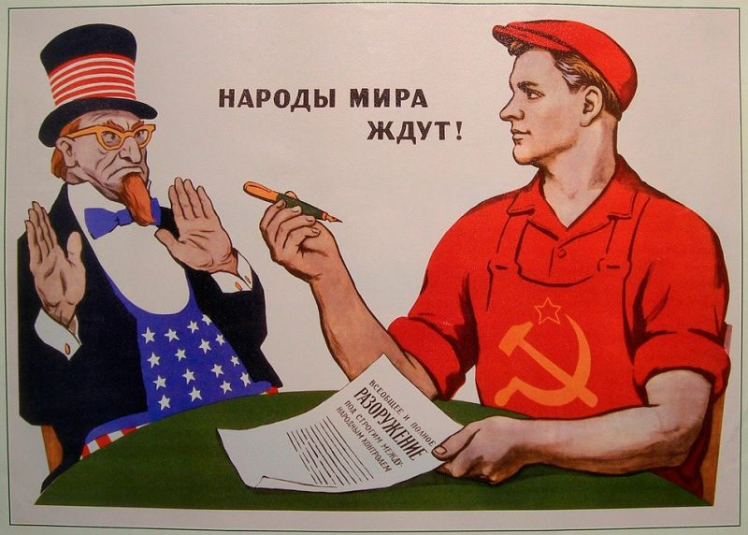

A Russian propaganda poster entitled: The People of World Are Waiting (for disarmament and peace), by V. Govorkov, 1962

